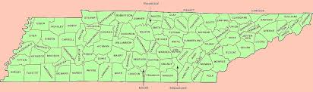

Prediction Price

Month and Year

City Name

HOUSING PRICES IN TENNESSEE

# of Bedrooms

Submit

Reset



Link to Map

Link to Home

Link to Zillow